**Data programming_Assignment_1**

**Question 1 C#**

What data type is each of the following?

|  |  |
| --- | --- |
| Questions | Data Type |
| 5 | Integer |
| 5.0 | float |
| 5 > 1 | Boolean |
| '5' | String |
| 5 * 2 | Integer |
| '5' * 2 | String |
| '5' + '2' | String |
| 5 / 2 | float |
| 5 % 2 | integer |
| {5, 2, 1} | List |
| 5 == 3 | Boolean |
| Pi (the number) | float |

**Question 2 C#**

Write (and evaluate) C# expressions that answer these questions:

a.How many letters are there in 'Supercalifragilisticexpialidocious'?

using System;

public class Countthestring

{

public static void Main()

{

String string1 = "Supercalifragilisticexpialidocious";

int count = 0;

for (int i = 0; i < string1.Length; i++)

{

if (string1[i] != ' ')

count++;

}

Console.WriteLine("Total number of characters in a string: " + count);

}

}

b. Does 'Supercalifragilisticexpialidocious' contain 'ice' as a substring?

using System;

class substring

{

static void Main(string[] args)

{

String str = "Supercalifragilisticexpialidocious";

String value = "ice";

Boolean result = str.Contains(value);

Console.WriteLine($"Does string contain specified substring? {result}");

}

}

c. Which of the following words is the longest: Supercalifragilisticexpialidocious, Honorificabilitudinitatibus, or Bababadalgharaghtakamminarronnkonn?

using System;

public class longestword

{

public static void Main()

{

string[] words = { "Supercalifragilisticexpialidocious", "Honorificabilitudinitatibus", "Bababadalgharaghtakamminarronnkonn" };

int longestLength = words.Max(w => w.Length);

Console.WriteLine("The longest word is {0} characters long.", longestLength);

}

}

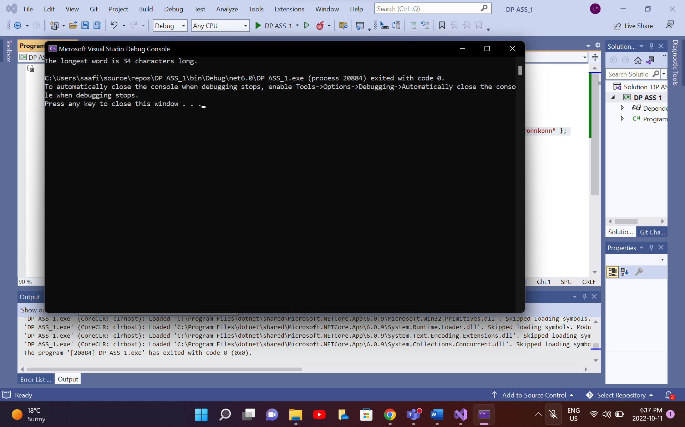

d. Which composer comes first in the dictionary: 'Berlioz', 'Borodin', 'Brian', 'Bartok', 'Bellini', 'Buxtehude', 'Bernstein'. Which one comes last?

class Program

{

static void Main()

{

string[] a = new string[]

{

"Berlioz",

"Borodin",

"Brian",

"Bartok",

"Bellini",

"Buxtehude",

"Bernstein",

};

Array.Sort(a);

foreach (string s in a)

{

Console.WriteLine(s);

}

}

}

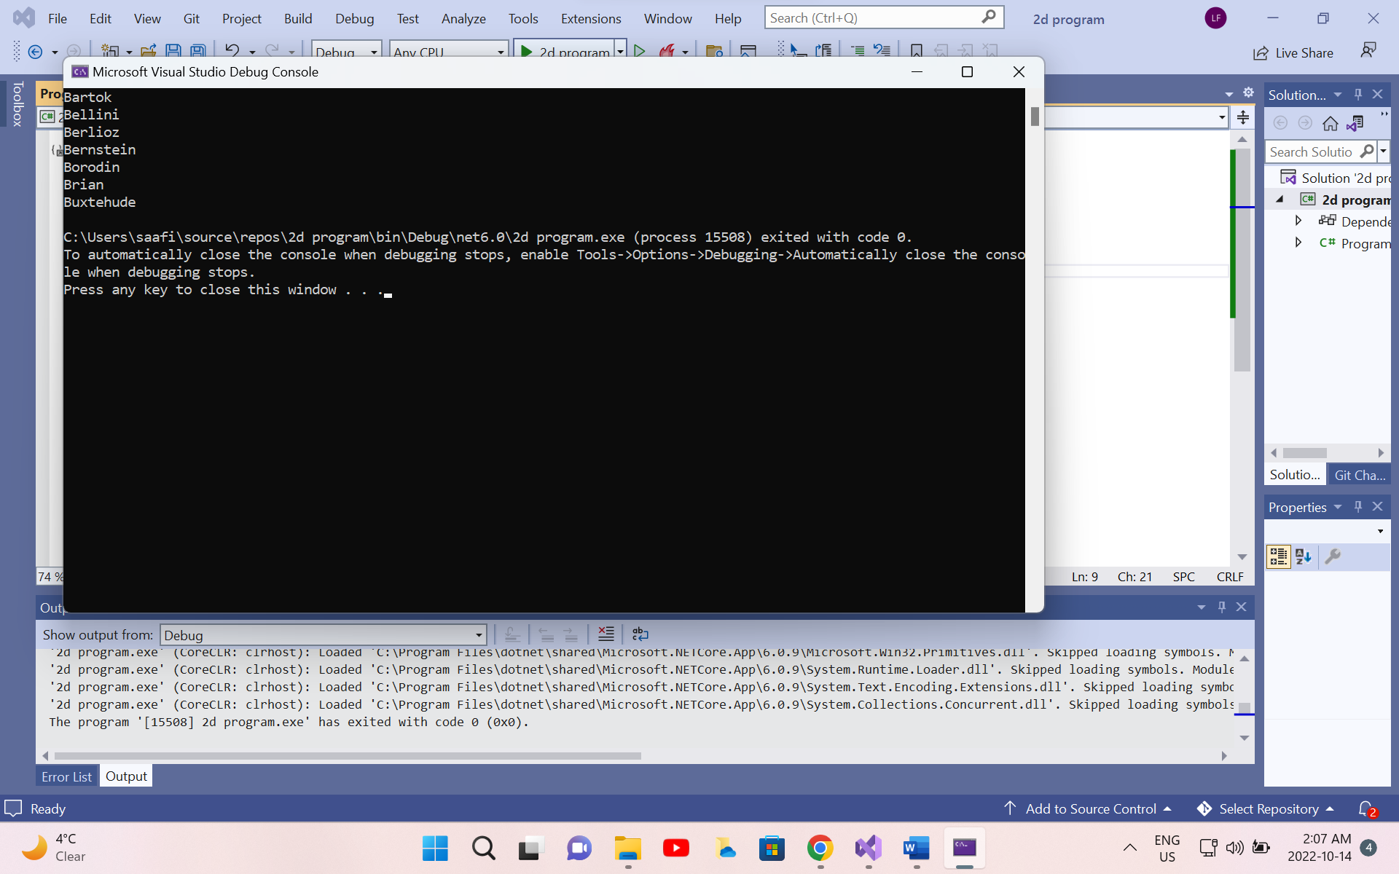

**Question 3 C#**

Implement function triangleArea(a,b,c) that takes as input the lengths of the 3 sides of a triangle and returns the area of the triangle. By Heron's formula, the area of a triangle with side lengths a, b, and c is s(s - a)(s -b)(s -c) , where s = (a+b+c)/2

using System;

public class AreaOfTriangle

{

public static void Main()

{

Console.Write("Enter the length of side 1:");

double side1 = Convert.ToDouble(Console.ReadLine());

Console.Write("Enter the length of side 2:");

double side2 = Convert.ToDouble(Console.ReadLine());

Console.Write("Enter the length of side 3:");

double side3 = Convert.ToDouble(Console.ReadLine());

double semiperimeter = (side1 + side2 + side3) / 2;

double Area = Math.Sqrt(semiperimeter * (semiperimeter - side1) * (semiperimeter - side2) * (semiperimeter - side3));

Console.Write("Area of a Triangle = " + Area);

Console.ReadKey();

}

}

**Question 4 C#**

Write a program in C# Sharp to separate odd and even integers in separate arrays.

using System;

public class oddoreven

{

public static void Main()

{

int[] arr1 = new int[10];

int[] arr2 = new int[10];

int[] arr3 = new int[10];

int i, j = 0, k = 0, n;

Console.Write("\n\nSeparate odd and even int in separate arrays:\n");

Console.Write("------------------------------------------------------\n");

Console.Write("Input the number of elements to be stored in the array :");

n = Convert.ToInt32(Console.ReadLine());

Console.Write("Input {0} elements in the array :\n", n);

for (i = 0; i < n; i++)

{

Console.Write("element - {0} : ", i);

arr1[i] = Convert.ToInt32(Console.ReadLine());

}

for (i = 0; i < n; i++)

{

if (arr1[i] % 2 == 0)

{

arr2[j] = arr1[i];

j++;

}

else

{

arr3[k] = arr1[i];

k++;

}

}

Console.Write("\nThe Even elements are : \n");

for (i = 0; i < j; i++)

{

Console.Write("{0} ", arr2[i]);

}

Console.Write("\nThe Odd elements are :\n");

for (i = 0; i < k; i++)

{

Console.Write("{0} ", arr3[i]);

}

Console.Write("\n\n");

}

}

**Question 5 C#**

1. Write a function inside(x,y,x1,y1,x2,y2) that returns True or False depending on whether the point (x,y) lies in the rectangle with lower left corner (x1,y1) and upper right corner

(x2,y2).

using System;

class GFG

{

static bool FindPoint(int x1, int y1, int x2,

int y2, int x, int y)

{

if (x > x1 && x < x2 &&

y > y1 && y < y2)

return true;

return false;

}

public static void Main()

{

int x1 = 0, y1 = 0,

x2 = 2, y2 = 3;

int x = -1, y = -1;

if (FindPoint(x1, y1, x2, y2, x, y))

Console.Write("Yes");

else

Console.Write("No");

}

}

5.b)Use function inside() from part a. to write an expression that tests whether the point (1,1) lies in both of the following rectangles: one with lower left corner (0.3, 0.5) and upper right corner (1.1, 0.7) and the other with lower left corner (0.5, 0.2) and upper right corner (1.1, 2).

using System;

public class Rectangle

{

public static void Main()

{

program(1, 2, 3.5, 4.6, 7.8, 5.8, 3.0, 7.9, 6.6, 2.3);

}

public static void program(int x, int y, double x1, double y1, double x2, double y2, double x3, double y3, double x4, double y4)

{

if (x > x1 && x < x2 && y > y1 && y < y2)

{

if (x > x3 && x < x4 && y > y3 && y < y4)

{

Console.WriteLine("True");

}

}

else

Console.WriteLine("False");

}

**Question 6 Python**

6. You can turn a word into pig-Latin using the following two rules (simplified):

• If the word starts with a consonant, move that letter to the end and append 'ay'. For example, 'happy' becomes 'appyhay' and 'pencil' becomes 'encilpay'. • If the word starts with a vowel, simply append 'way' to the end of the word. For example, 'enter' becomes 'enterway' and 'other' becomes 'otherway' . For our purposes, there are 5 vowels: a, e, i, o, u (so we count y as a consonant). Write a function pig() that takes a word (i.e., a string) as input and returns its pigLatin form. Your function should still work if the input word contains upper case characters. Your output should always be lower case however.

vowels = ['a','e','i','o','u']

def pig(word):

if word[0].lower() in vowels:

print(word.lower() + 'way')

else:

first_letter = word[0]

print(word[1:].lower()+first_letter.lower()+'ay')

**Question 7 Python**

File bloodtype1.txt records blood-types of patients (A, B, AB, O or OO) at a clinic. Write a function bldcount() that reads the file with name name and reports (i.e., prints) how many patients there are in each bloodtype.

def bldcount(filename):

x = open(filename,'r')

words = x.readline()

lst = []

blood_typs = ['A','B','AB','O','OO']

lst.append(words.split(" "))

for blood_typ in blood_typs:

print("There are {} patients of blood type {}.".format(lst[0].count(blood_typ),blood_typ))

bldcount('bloodtype.txt')

**Question 8 Python**

Write a function curconv() that takes as input:

1. a currency represented using a string (e.g., 'JPY' for the Japanese Yen or 'EUR' for the Euro) 2. an amount and then converts and returns the amount in US dollars

**def** curconv(currency,amount):

currencies **=** {}

cur_file **=** open('currencies.txt')

lines **=** cur_file**.**readlines()

**for** x **in** lines:

currencies[x[:3]**.**strip()] **=** x[4:]**.**split("\t")

value **=** currencies[currency][0]**.**strip()

print(amount **\*** float(value))

curconv('JPY', 100)

1.241401

curconv('JPY', 100)

1.241401

**Question 9 Python**

Each of the following will cause an exception (an error).

Identify what type of exception each will cause.

|  |  |
| --- | --- |
| Trying to add incompatible variables, as in adding 6 + ‘a’ | Unsupported type |
| Referring to the 12th item of a list that has only 10 items | Out of index |
| Using a value that is out of range for a function’s input, such as calling math.sqrt(-1.0) | domain error |
| Using an undeclared variable, such as print(x) when x has not been defined | variable not defined |
| Trying to open a file that does not exist, such as mistyping the file name or looking in the wrong directory | No such directory found |

**Question 10 Python**

Encryption is the process of hiding the meaning of a text by substituting letters in the message with other letters, according to some system. If the process is successful, no one but the intended recipient can understand the encrypted message. Cryptanalysis refers to attempts to undo the encryption, even if some details of the encryption are unknown (for example, if an encrypted message has been intercepted). The first step of cryptanalysis is often to build up a table of letter frequencies in the encrypted text. Assume that the string letters is already defined as 'abcdefghijklmnopqrstuvwxyz'. Write a function called frequencies() that takes a string as its only parameter, and returns a list of integers, showing the number of times each character appears in the text. Your function may ignore any characters that are not in letters.

def frequencies(text):

alphabets = ('a','b','c','d','e','f','g','h','i','j','k','l','m','n','o','p','q','r','s','t','u','v','w','x','y','z')

total_char = []

alpha_dict = {}

for word in text:

for char in word:

if char.isalpha():

total_char.append(char)

for char in alphabets:

if char in total_char:

alpha_dict[char] = total_char.count(char)

else:

alpha_dict[char] = 0

print(list(alpha_dict.values()))

**frequencies('The quick red fox got bored and went home.')**

**[1, 1, 1, 3, 5, 1, 1, 2, 1, 0, 1, 0, 1, 2, 4, 0, 1, 2, 0, 2, 1, 0, 1, 1, 0, 0]**

**frequencies('apple')**

**[1, 0, 0, 0, 1, 0, 0, 0, 0, 0, 0, 1, 0, 0, 0, 2, 0, 0, 0, 0, 0, 0, 0, 0, 0, 0]**

**frequencies('orange')**

**[1, 0, 0, 0, 1, 0, 1, 0, 0, 0, 0, 0, 0, 1, 1, 0, 0, 1, 0, 0, 0, 0, 0, 0, 0, 0]**

